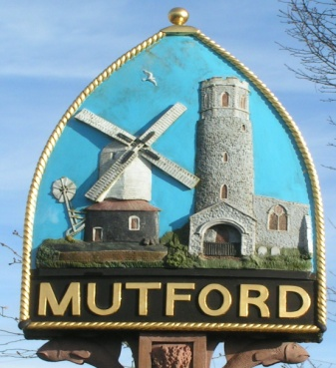
Mutford
PARISH COUNCIL

Notice is hereby given of an Additional Ordinary Meeting of the Parish Council

The meeting will be held by video conference due to Covid-19 restrictions

Monday 18th January 2021 Commencing at 7.30pm

_ _ _ _ _ _ _ _ _ _ _ _ _ _ Clerk
AGENDA

- Apologies for absence

- Declaration of interest personal or prejudicial to this agenda

- Precept request for 2021/22

- Planning
DC/20/5080/FUL | Proposed two storey side and rear extensions | Annexe At Holly Farm 31 Holly Lane Mutford Beccles Suffolk NR34 7UX

- To note the date of the next meeting Monday 1st February 2021 7.30pm

Clerk to the Parish Council: John Armstrong
‘Sandlewood’, Hulver Road , Mutford Beccles Suffolk NR34 7UL
Tel: 01502 476418 Email: jamutfordpc@btinternet.com

