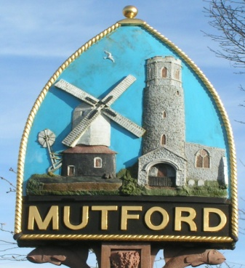
Mutford
PARISH COUNCIL

Notice is hereby given of an Ordinary Meeting of the Parish Council

The meeting will be held by video conference due to Covid-19 restrictions

Monday 1st February 2021 Commencing at 7.30pm

_ _ _ _ _ _ _ _ _ _ _ _ _ _ Clerk
AGENDA

- Apologies for absence

- Declaration of interest personal or prejudicial to this agenda

- Minutes of the meeting of 7th December 2020 and the additional meeting 18th January 2021

- Matters arising not otherwise on the agenda

- Chairman’s Item

- Correspondence
Letters/Email from:

- Finance
- To approve payments outstanding
Bin emptying and playground
Newsletter and APM Printing
- Account Balance
- To note the precept request for 2021/22 has been sent to ESC
- PAYE Administration for PAYE Clerk to report

- Planning

- To consider any planning applications.
None
- To receive outcomes of planning applications from ESC
DC/20/3366/OUT | Outline Application (With Some Matters Reserved)- Construction of 3 No pairs of semi-detached houses. Formation of new vehicular access and associated parking and landscaping works. | Land To The North Of Chapel Road Mutford Suffolk NR34 7UU Permitted
DC/20/5080/FUL | Proposed two storey side and rear extensions | Annexe At Holly Farm 31 Holly Lane Mutford Beccles Suffolk NR34 7UX Awaiting decision

- Community Partnership talking benches project. Clerk to report

- Playground.
- Playground report. To include replacement of safety surfaces on pieces of equipment. Grant from Cllrs Ceresa and Rivett

- Reports
- ESC
- SCC
- Police

- Update on formation of Neighbourhood Watch Group and community speed watch

- Adjournment for questions from members of the public.

Re-opening of the meeting

- Any other business of which due notice has been given

- Requests for items to be placed on the agenda for the next meeting

- To note the date of the next meeting Monday 1st March 7.30pm

Clerk to the Parish Council: John Armstrong
‘Sandlewood’, Hulver Road , Mutford Beccles Suffolk NR34 7UL
Tel: 01502 476418 Email: jamutfordpc@btinternet.com

