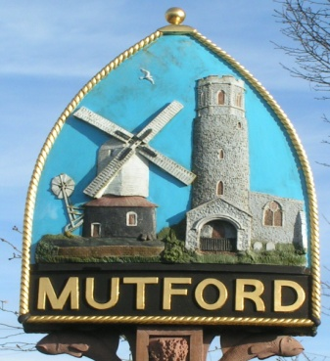
Mutford
PARISH COUNCIL

Notice is hereby given of an Ordinary Meeting of the Parish Council

The meeting will be held by video conference due to Covid 19 restrictions

Monday 1st June 2020 Commencing at 7.30pm

_ _ _ _ _ _ _ _ _ _ _ _ _ _ Clerk
AGENDA

- Apologies for absence

- Declaration of interest personal or prejudicial to this agenda

- Minutes of the meeting of 4th May 2020

- Matters arising not otherwise on the agenda

- Correspondence
Letters/Email from:
None

- Finance
- To approve payments outstanding
Bin emptying and playground
Clerk’s pay and PAYE April/June 2020
- To approve the accounts for 2019 2020
- To receive the Internal Audit Report for 2019 2020
- To approve the Annual Governance Statement
- To approve the Accounting Statement 2019 2020
- Account balances £8247.87

- Planning
- To consider any planning applications.
DC/20/1892/FUL | Timber frame- two storey rear extension. Addition of bifolds and roof. Re-paint property black. | Meadowview Hulver Road Mutford Beccles Suffolk NR34 7UW
- To receive outcomes of planning applications from WDC
None
- Mirrors at Beulah Hall Highways update

- Community Chain
Update from Cllr Sheahan

- Annual Parish Meeting
To consider position of APM

- Any other business of which due notice has been given.
- Playground report

- Reports
- East Suffolk Council
- SCC
- Police

- Adjournment for questions from members of the public.

Re-opening of the meeting

- Requests for items to be placed on the agenda for the next meeting

- To note the date of the next meeting Monday 6th July 7.30pm

Clerk to the Parish Council: John Armstrong
‘Sandlewood’, Hulver Road , Mutford Beccles Suffolk NR34 7UL
Tel: 01502 476418 Email: jamutfordpc@btinternet.com

