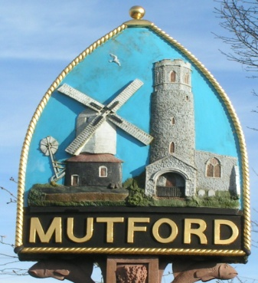
Mutford
PARISH COUNCIL

Notice is hereby given of an Ordinary Meeting of the Parish Council

The meeting will be held by video conference due to Covid-19 restrictions

Monday 5th October 2020 Commencing at 7.30pm

_ _ _ _ _ _ _ _ _ _ _ _ _ _ Clerk
AGENDA

- Apologies for absence

- Declaration of interest personal or prejudicial to this agenda

- Minutes of the meeting of 7th September 2020

- Matters arising not otherwise on the agenda

- Correspondence
Letters/Email from:

- Finance
- To approve payments outstanding
Bin emptying and playground TBA
Newsletter and APM Printing £64.00
Replacement seat for cradle swing £102.00
Installation of the defibrillator £93.16
- To note receipt of the 2nd part of the precept 2020-21 £2000.00
- Account balances
- To confirm payment of Council Insurance 2020/21

- Planning
- To consider any planning applications.
DC/20/3366/OUT | Outline Application (With Some Matters Reserved)- Construction of 3 No pairs of semi-detached houses. Formation of new vehicular access and associated parking and landscaping works. | Land To The North Of Chapel Road Mutford Suffolk NR34 7UU
- To receive outcomes of planning applications from WDC
DC/20/2819/FUL | Demolish existing barn and build a Three Bay Oak Framed Cart Shed 6 meters deep by 9 meter wide. One bay will be enclosed with hard wood barn doors, to give owners secure storage and parking area. The further two bays will be left open for storage. | Ash Farm Dairy Lane Mutford Beccles Suffolk NR34 7QJ Permitted
- Planning application Rushmere Clerk to update
- Appeals AP/20/0053/REFUSE | Construction of single storey dwelling, drive access, fencing, materials | Rivendell Church Road Mutford Beccles Suffolk NR34 7UZ Appeal in progress

- Community Chain
Update from Cllr Sheahan

- Defibrillator Clerk to report

- Any other business of which due notice has been given.
- Playground report.

- Reports
- East Suffolk Council
- SCC
- Police

- Update on formation of Neighbourhood Watch Group

- Adjournment for questions from members of the public.

Re-opening of the meeting

- Requests for items to be placed on the agenda for the next meeting

- To note the date of the next meeting Monday 2nd November 2020 7.30pm

Clerk to the Parish Council: John Armstrong
‘Sandlewood’, Hulver Road , Mutford Beccles Suffolk NR34 7UL
Tel: 01502 476418 Email: jamutfordpc@btinternet.com

