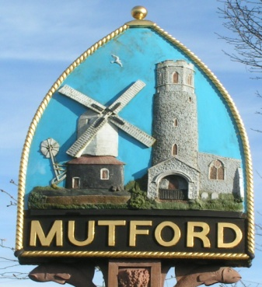
Mutford
PARISH COUNCIL

Notice is hereby given of an Ordinary Meeting of the Parish Council

The meeting will be held by video conference due to Covid-19 restrictions

Monday 6th July 2020 Commencing at 7.30pm

_ _ _ _ _ _ _ _ _ _ _ _ _ _ Clerk
AGENDA

- Apologies for absence

- Declaration of interest personal or prejudicial to this agenda

- Minutes of the meeting of 1st June 2020

- Matters arising not otherwise on the agenda

- Correspondence
Letters/Email from:
Carlton Colville Town Council about permissive path land adjacent to Mutford Wood

- Finance
- To approve payments outstanding
Bin emptying and playground
Newsletter and APM Printing
- Account balances £8247.87

- Planning
- To consider any planning applications.
None
- To receive outcomes of planning applications from WDC
DC/20/1892/FUL | Timber frame- two storey rear extension. Addition of bifolds and roof. Re-paint property black. | Meadowview Hulver Road Mutford Beccles Suffolk NR34 7UW
DC/20/1951/CLE | Certificate of Lawful Use (Existing) - Use of the property colonising as a residence by someone who is not employed or last employed in agriculture or in an industry mainly dependant on agriculture or the dependent of such a person. | Coligny Mutford Wood Mutford Lowestoft Suffolk NR33 8HF (Clerk to report)
- Planning application Rushmere Clerk to update
- Mirrors at Beulah Hall Highways update

- Community Chain
Update from Cllr Sheahan

- Annual Parish Meeting
Update

- Any other business of which due notice has been given.
- Playground report to include

- Reports
- East Suffolk Council
- SCC
- Police

- Adjournment for questions from members of the public.

Re-opening of the meeting

- Requests for items to be placed on the agenda for the next meeting

- To note the date of the next meeting Monday 7th September 2020 7.30pm

Clerk to the Parish Council: John Armstrong
‘Sandlewood’, Hulver Road , Mutford Beccles Suffolk NR34 7UL
Tel: 01502 476418 Email: jamutfordpc@btinternet.com

