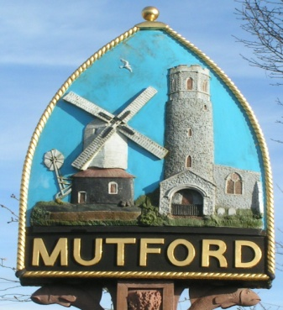
Mutford
PARISH COUNCIL

Notice is hereby given of an Ordinary Meeting of the Parish Council

The meeting will be held at Mutford Village Hall

Tuesday 25th May 2021 Commencing at 7.00pm

_ _ _ _ _ _ _ _ _ _ _ _ _ _ Clerk
AGENDA

- Apologies for absence

- Declaration of interest personal or prejudicial to this agenda

- Minutes of the meeting of 6th May 2021

- Matters arising not otherwise on the agenda

- Chairman’s Item

- Correspondence
Letters/Email from:

- Finance
- To approve payments outstanding
- Account Balance £21391.52
- To receive and approve the accounts for 2021/22

- Planning
- To consider any planning applications.
DC/21/2288/FUL | Erection of Summerhouse | Stony Hill Cottage Hulver Road Mutford Beccles Suffolk NR34 7UL
- Consultation on Development of 950 houses in Beccles
- To receive outcomes of planning applications from ESC
DC/21/1459/FUL | The original application for the siting of a cabin on my land was applied for in February 2016 ( DC/16/0688/FUL ) and permission granted in April 2016. Permission at the time was given for a period of 5 years, as this is now coming to an end I wish to now apply for full planning permission to be granted for my cabin to remain, as I still require secure storage for grass cutting equipment and the need for a shelter. | Land Adjacent To Mutford Wood Mutford Suffolk Awaiting decision
- Appeals
AP/21/0005/REFUSE | Demolition of existing dwelling and replacement with three detached bungalows, garages and all associated works. | Red Lodge The Street North Cove Beccles Suffolk NR34 7PU Awaiting decision

- Playground.
- Playground report. Replacement of safety surfaces at the playground. Clerk to update.

- Annual Parish Meeting
To consider and make arrangements for the Annual Parish Meeting

- Casual Vacancy Clerk to report

- Reports
- ESC
- SCC
- Police

- Adjournment for questions from members of the public.

Re-opening of the meeting

- Any other business of which due notice has been given
Dates of future meetings

- Requests for items to be placed on the agenda for the next meeting

- To determine the date for the next meeting

Clerk to the Parish Council: John Armstrong
‘Sandlewood’, Hulver Road , Mutford Beccles Suffolk NR34 7UL
Tel: 01502 476418 Email: jamutfordpc@btinternet.com

