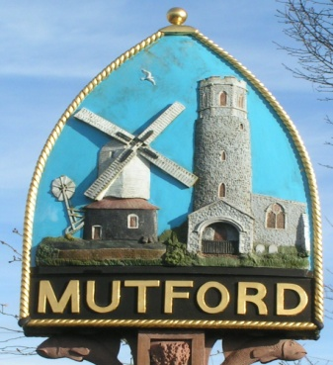
Mutford
PARISH COUNCIL

Minutes of the Additional Ordinary Meeting of the Council
held by video conferencing
on Monday 18th January 2021
Commencing at 7.30pm

104/20 Present
Cllrs. Carl O’Brien CBE (Chairman), Neil Glendinning Jenny Sheahan, Richard Read, David Greenacre, Theresa Robinson, Martin Warnes
In Attendance J. Armstrong (Clerk)

105/20 Apologies for absence
There were no apologies

106/20 Declarations of Interest
None

107/20 Finance
107/20/1 Precept request for 2021/2022
The clerk presented a budget forecast for 2021/22 (copy previously circulated). The clerk said that Council should consider likely expenditure up to 2023 against the precept. It should also consider the amount of grant income that might be available to assist the Council in meeting its costs.
Following a lengthy discussion, it was agreed that a precept of £6000.00 be requested. It was further agreed that details of the precept should be included in the February Issue of the news letter to explain the reasons for the increase.

108/20 Planning
96/20/1 Planning Applications
DC/20/5080/FUL Proposed two storey side and rear extensions Annexe At Holly Farm 31 Holly Lane Mutford Beccles Suffolk NR34 7UX
Following discussion, it was agreed that the Council had no strong objection to this application but is concerned about the overall size of the property against the size of the plot. The Council noted the concerns of neighbours about noise and disruption during building work if the application was approved. The clerk was asked to respond to ESC asking that the application meets the requirements for the footprint of the dwelling against the size of the plot and that the applicant should ensure that noise and disturbance are kept to a minimum.

109/20 Date and time of next meeting.
To note the date of the next meeting will be Monday 1st February 2021 7.30pm

The meeting closed at 8.10pm

