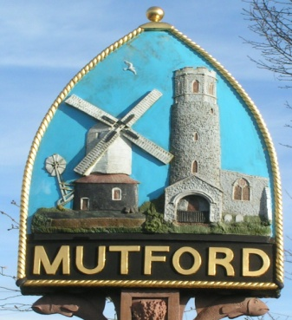
Mutford
PARISH COUNCIL

Minutes of the Planning Meeting of the Council
held by video conferencing
on Tuesday 23rd March 2021
Commencing at 7.30pm

139/20 Present
Cllrs. Carl O’Brien CBE (Chairman), Neil Glendinning Jenny Sheahan, Richard Read, Theresa Robinson, Martin Warnes
In Attendance J. Armstrong (Clerk)

140/20 Apologies for absence
There were no apologies

141/20 Declarations of Interest
None

142/20 Planning
Planning Applications

- DC/21/0936/FUL | Construction of olive-green steel open sided shelter for machinery and hay/straw storage | 15 Holly Lane Mutford Beccles Suffolk NR34 7UX
Following a lengthy discussion, it was agreed that the response should be delayed for Council to consider any responses from residents. The Clerk was instructed to prepare a response to meet the deadline for it. Members were particularly concerned about the size of the proposed structure compared to the uses to which the applicant has stated.

- DC/21/0916/FUL | Proposed extensions and alterations. | 1 Oceans Gift Hulver Road Mutford Beccles Suffolk NR34 7UL
Following discussion, Council had a number of concerns with this application it was agreed that Council had no objection to this application.

143/20 Date and time of next meeting.
To note the date of the next meeting will be Monday 12th April 7.30pm

The meeting closed at 8pm

